***ASSIGNMENT 1***

1. EC2 DASHBOARD WITH INSTANCE LISTED

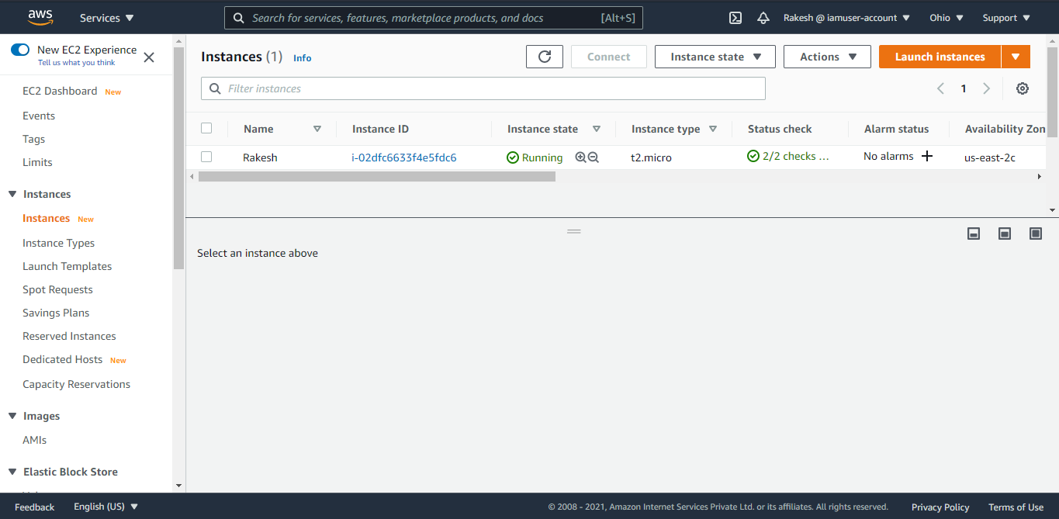

1. EC2 INSTANCE DETAILS

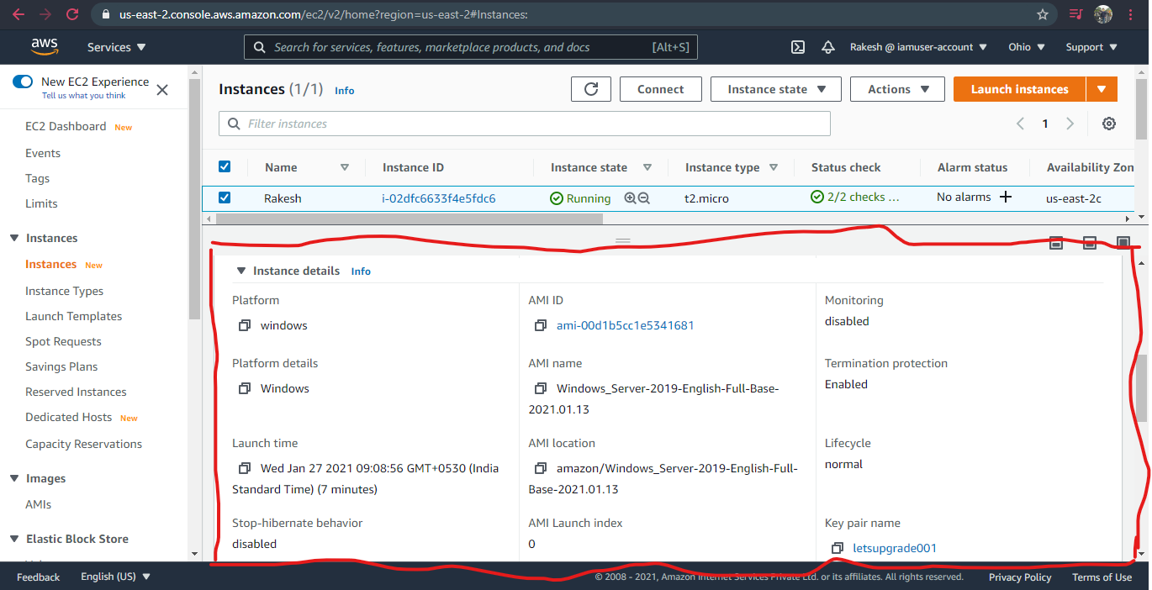

1. WINDOWS SCREEN AFTER SUCCESSFUL LAUNCH

